**How to create a project in visual studio**

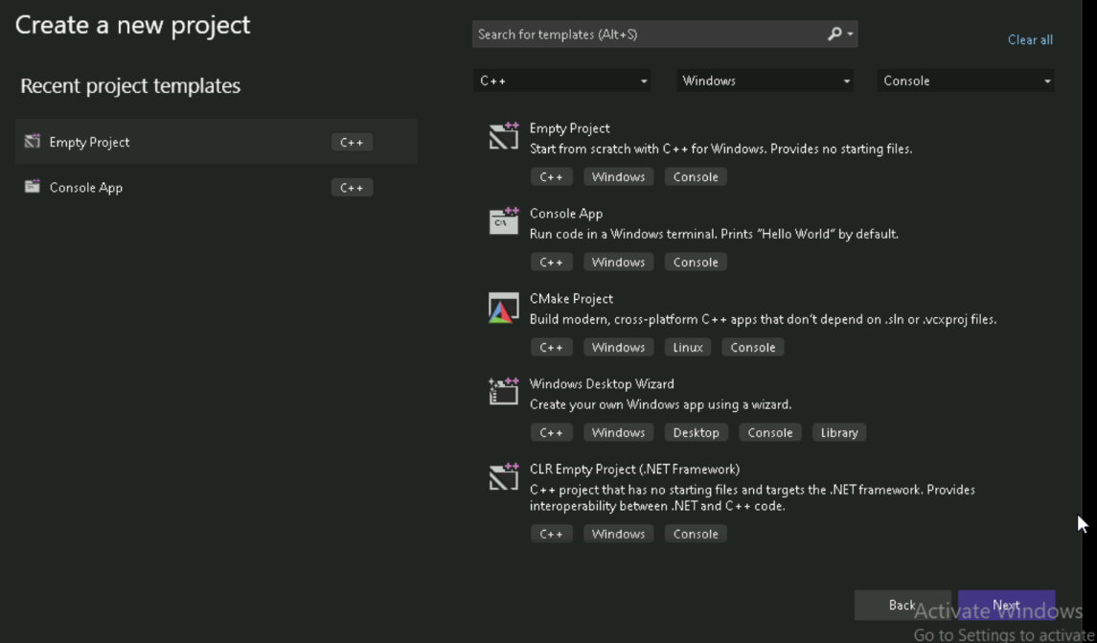

1. Open vs
2. Click on “create a new project”
3. Choose the project template
4. Click “next”
5. Configure your project(project name,folder,solution name)
6. Click”create”

**To change the output directory to bin**

1. Right click on the project namein the solution explorer
2. Click on “properties”
3. In configuration properties->general->output directory
4. Change from $(solution)$(configuration)\

To $(solution)bin\$(configuration)\

1. Click “apply” and “ok”

Now the .exe file will be placed in the bin\debug folder based on the build configuration.

To redirect object files to the obj directory in visual studio

1. Right click the project name on solution explorer --> select “properties”
2. Go to configuration properties 🡪c/c++ 🡪output files
3. Find the field intermediate directory
4. Change from $(solutionDir)$(platform)\$(configuration)\
5. To $(solutionDir)obj\$(platform)\$(configuration)\
6. Click apply and ok

This will save all generated .obj files inside obj folder

**Steps to set additional include directories**

1. Right click the project name on solution explorer --> select “properties”
2. **C++ 🡪 general 🡪 additional include directories**
3. Click the dropdown🡪 choose “**edit**”
4. Add directory path where header files are located
5. Click on ok then apply

In a typical software project ,files are organized into folders to maintain clarity and efficiency during development and building.

Src – contains source code files

Inc – holds header files

Bin – stores exe files

Obj - stores intermediary files

Lib – includes external or generated libraries